**COMPARING THE SOCIO-ECONOMIC FACTORS OF GDP, MORTALITY, AND IMMUNIZATION ON LIFE EXPECTANCY BASED ON CORRELATIONS  
VERSUS  
THE SOCIO-ECONOMIC FACTORS OF TOTAL EXPENDITURE AND ALCOHOL ON LIFE EXPECTANCY BASED ON CORRELATIONS**

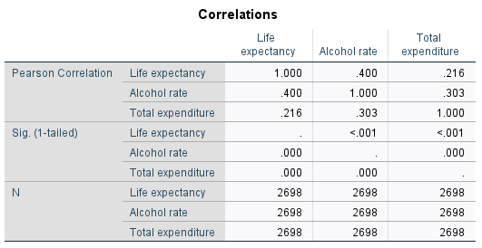

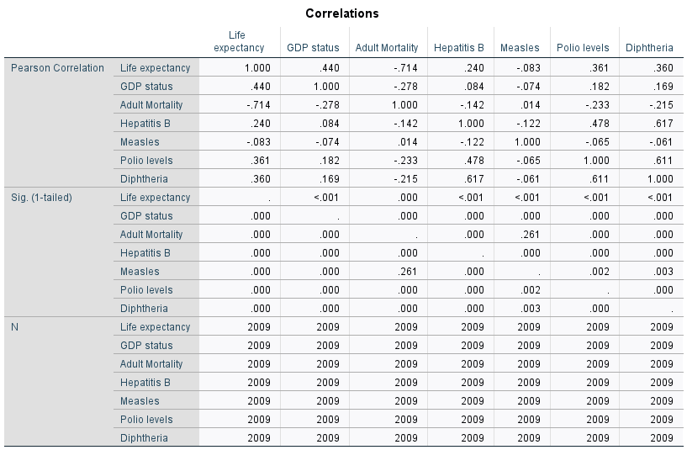

**Report summary on validation**

* In the first model, all predictors (Alcohol and Total expenditure) had a significant impact on life expectancy.
* In the second model, the most significant predictors influencing life expectancy were GDP, Hepatitis B, Measles, and Polio, while Adult mortality had the least significant effect.